INDIA’S AGRICULTURAL CROP PRODUCTION ANALYSIS

Introduction:

The agriculture sector employs nearly half of the workforce in the country. However, it contributes to 17.5% of the GDP (at current prices in 2015-16). 

Over the past few decades, the manufacturing and services sectors have increasingly contributed to the growth of the economy, while the agriculture sector’s contribution has decreased from more than 50% of GDP in the 1950s to 15.4% in 2015-16 (at constant prices).

India’s production of food grains has been increasing every year, and India is among the top producers of several crops such as wheat, rice, pulses, sugarcane and cotton. It is the highest producer of milk and second highest producer of fruits and vegetables.  In 2013, India contributed 25% to the world’s pulses production, the highest for any one country, 22% to the rice production and 13% to the wheat production.  It also accounted for about 25% of the total quantity of cotton produced, besides being the second highest exporter of cotton for the past several years

Key issues affecting agricultural productivity include the decreasing sizes of agricultural land holdings, continued dependence on the monsoon, inadequate access to irrigation, imbalanced use of soil nutrients resulting in loss of fertility of soil, uneven access to modern technology in different parts of the country, lack of access to formal agricultural credit, limited procurement of food grains by government agencies, and failure to provide remunerative prices to farmers.

Some of the recommendations made by committees and expert bodies over the years include bringing in agricultural land leasing laws, shifting to micro-irrigation techniques to improve efficiency of water use, improving access to quality seeds by engaging with the private sector, and introducing a national agricultural market to allow the trading of agricultural produce online.

The country’s requirement for food grains in order to provide for its population is projected to be 300 million tonnes by 2025. The estimate of food grains production in 2015-16 is 252 million.  This implies that the crop output needs to grow at an annual average of 2%, which is close to the current growth trend.

Despite high levels of production, agricultural yield in India is lower than other large producing countries.  Agricultural yield is the quantity of a crop produced on one unit of land.  Agricultural yield of food grains has increased by more than four times since 1950-51, and was 2,070 kg/hectare in 2014-15.

Total production of food grains increased from 51 million tonnes in 1950-51 to 252 million tonnes in 2015-16. According to the second advance estimate by the Ministry of Agriculture, food grains production is estimated to be 272 million tonnes in 2016-17.

  The production of wheat and rice took off after the green revolution in the 1960s, and as of 2015-16, wheat and rice accounted for 78% of the food grains production in the country.

**EMPATHY MAPPING**

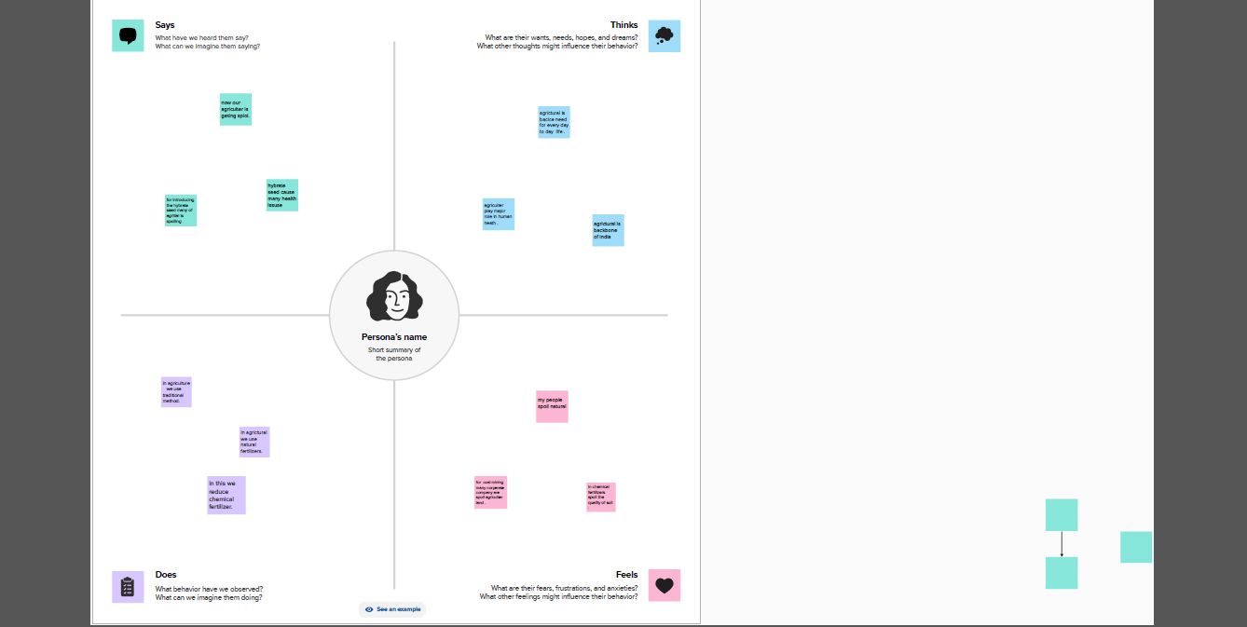

**BRAIN STORM**

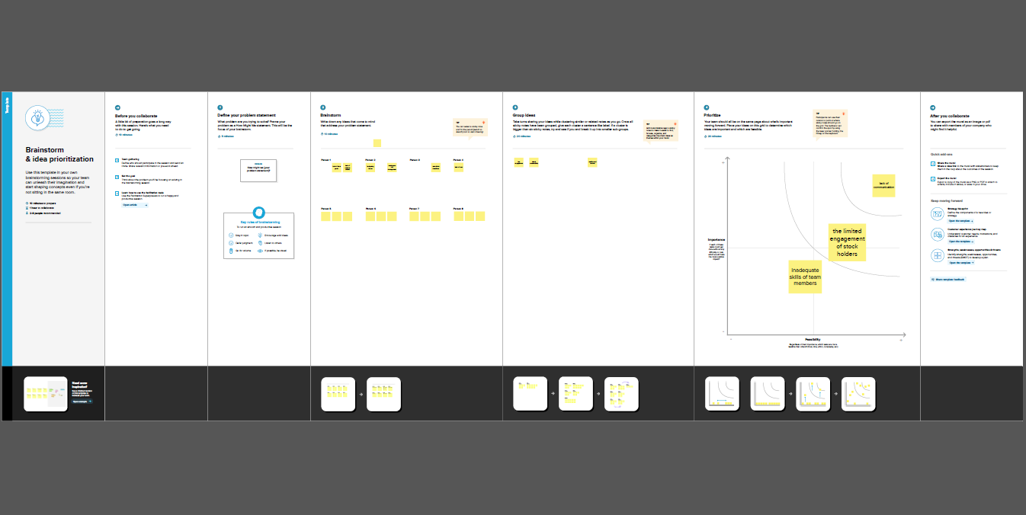

**RESULT**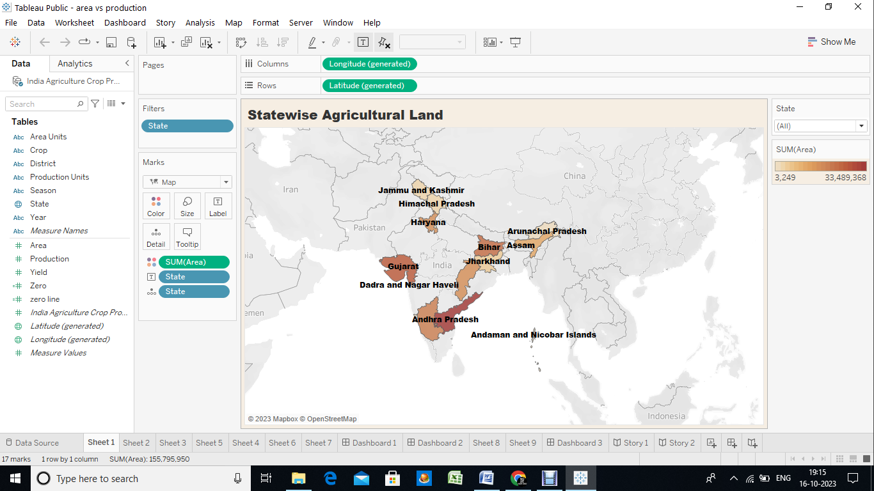

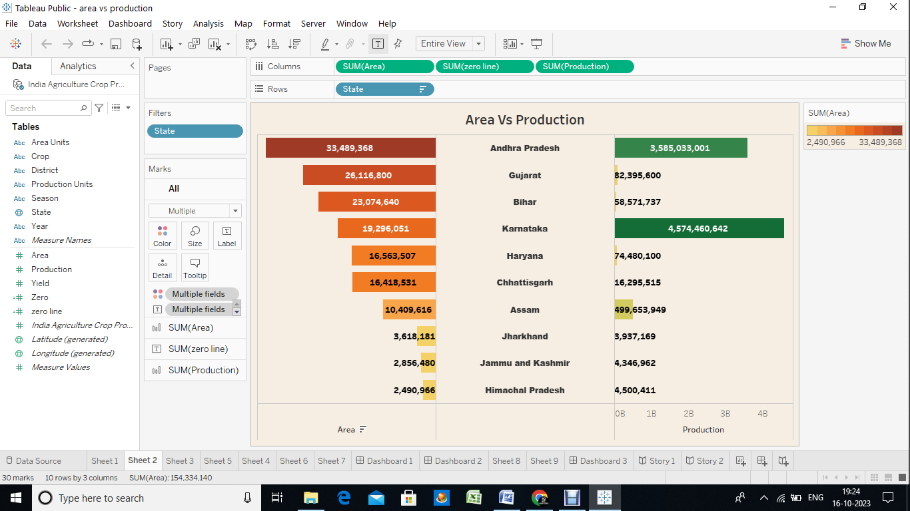

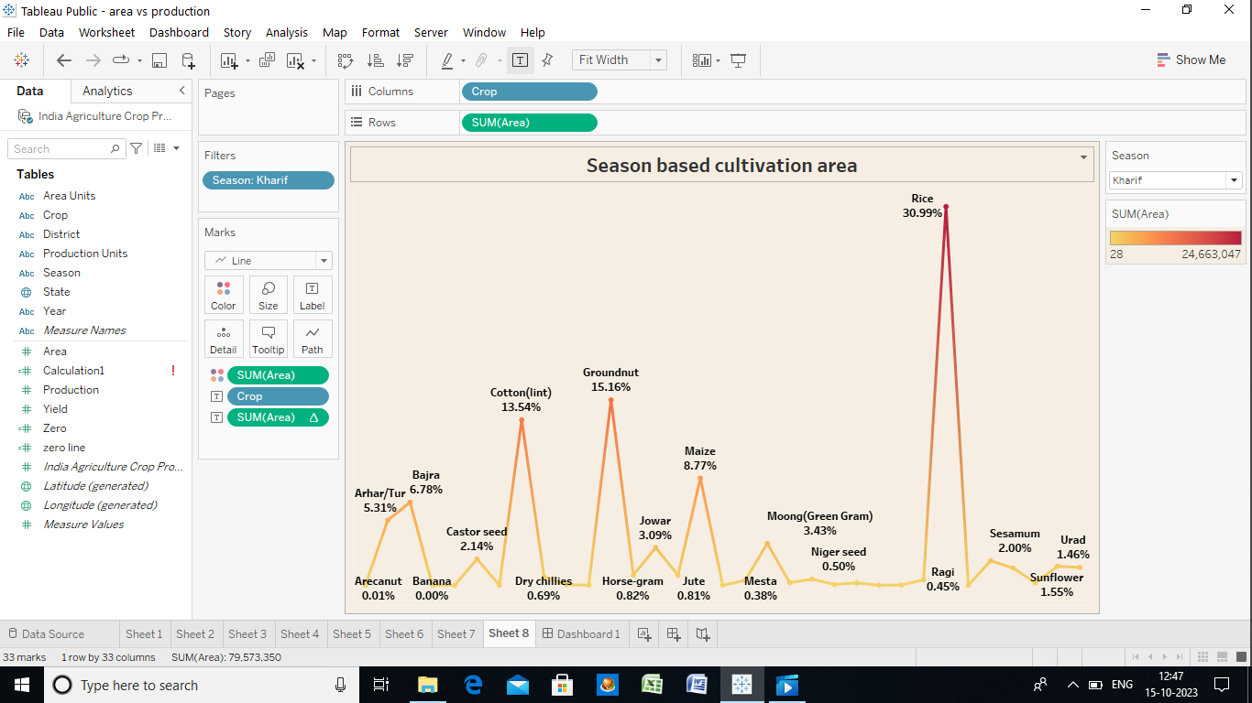

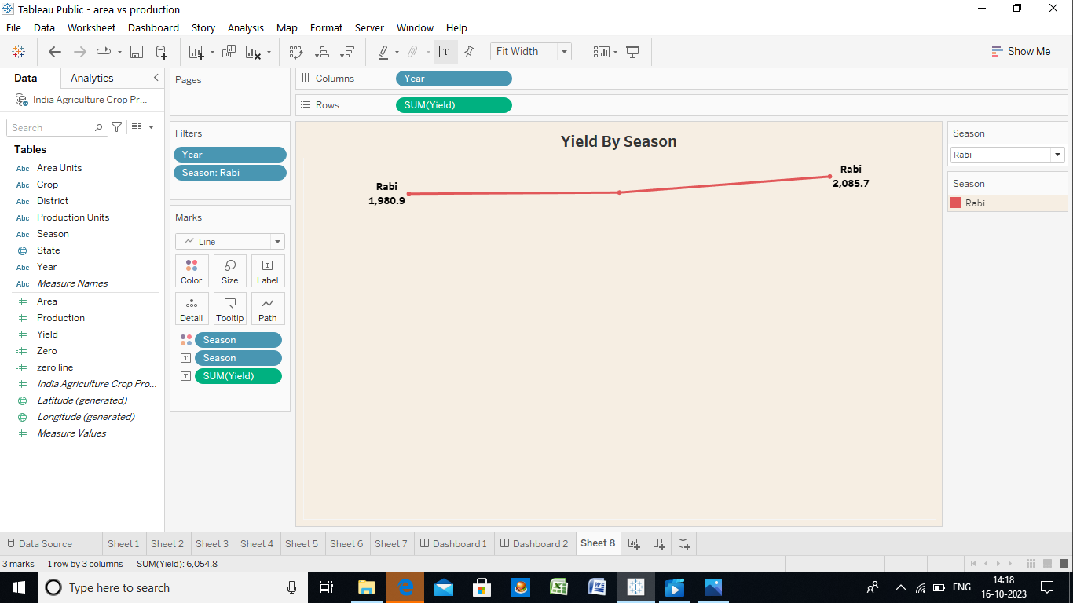

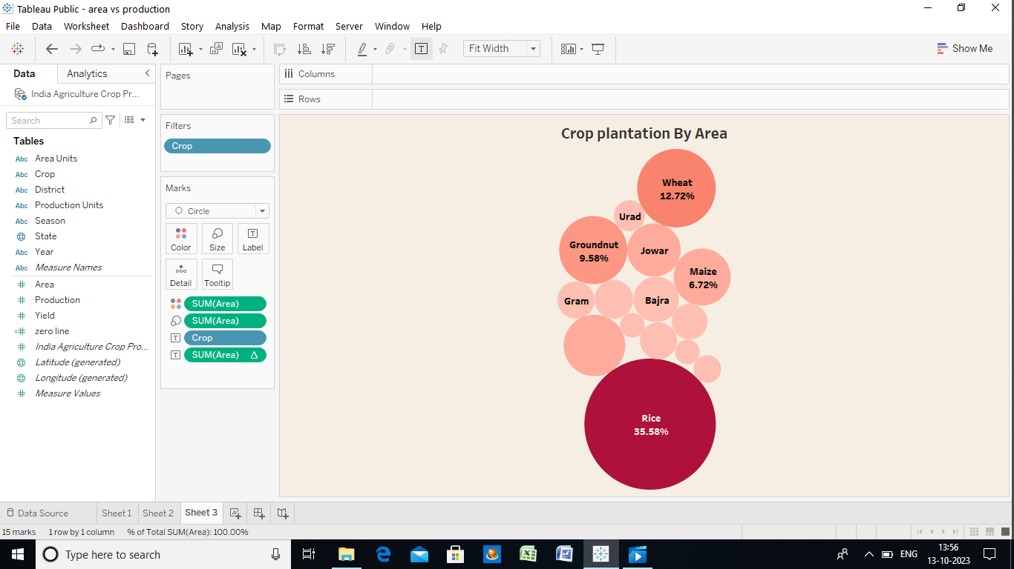

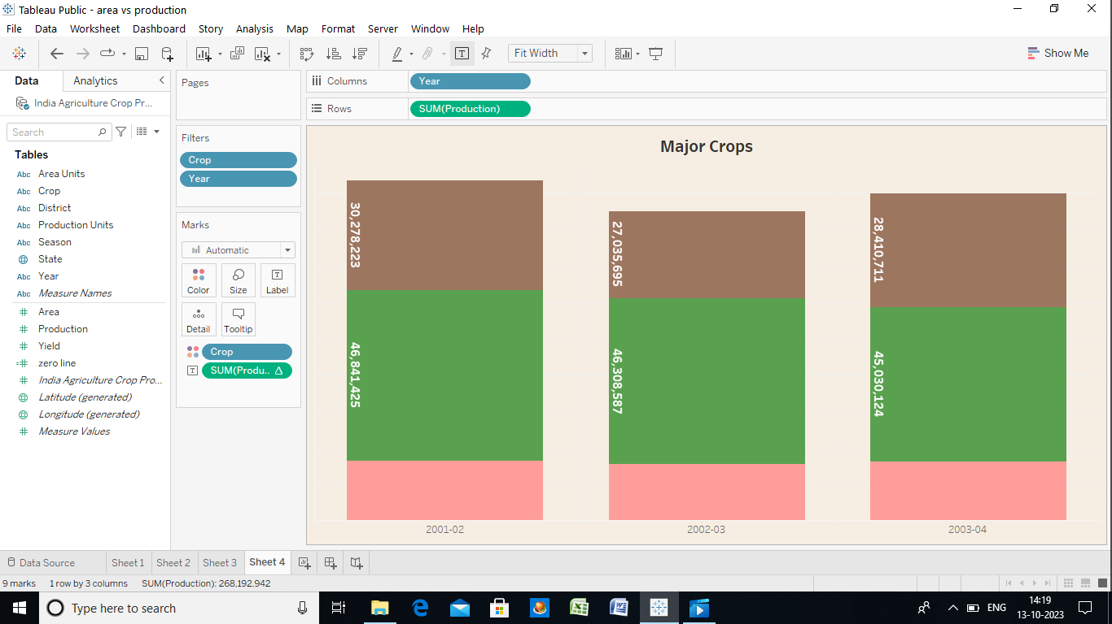

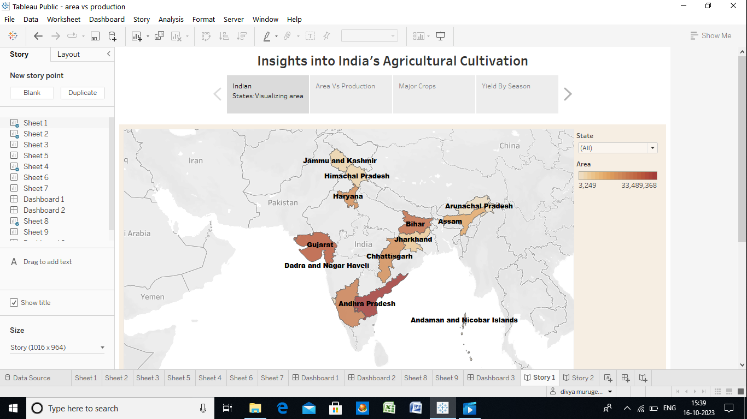

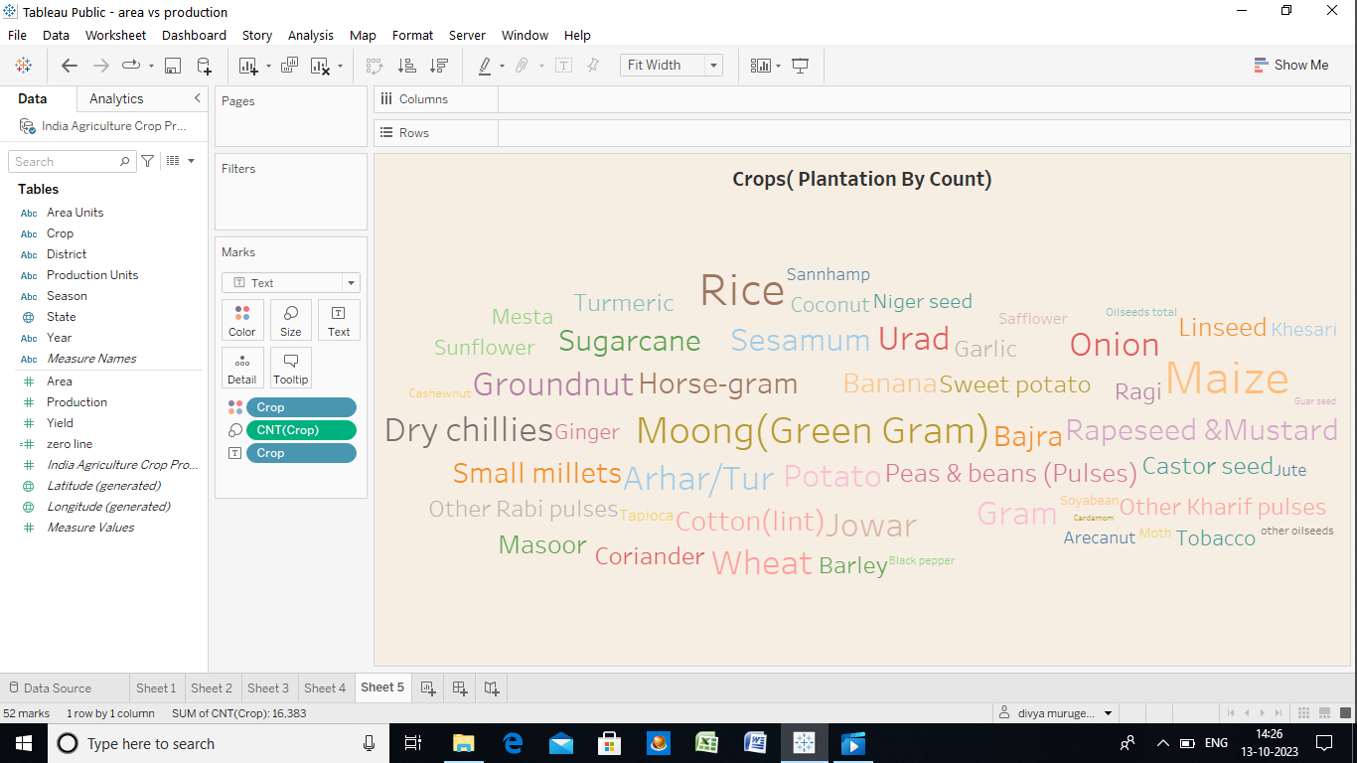

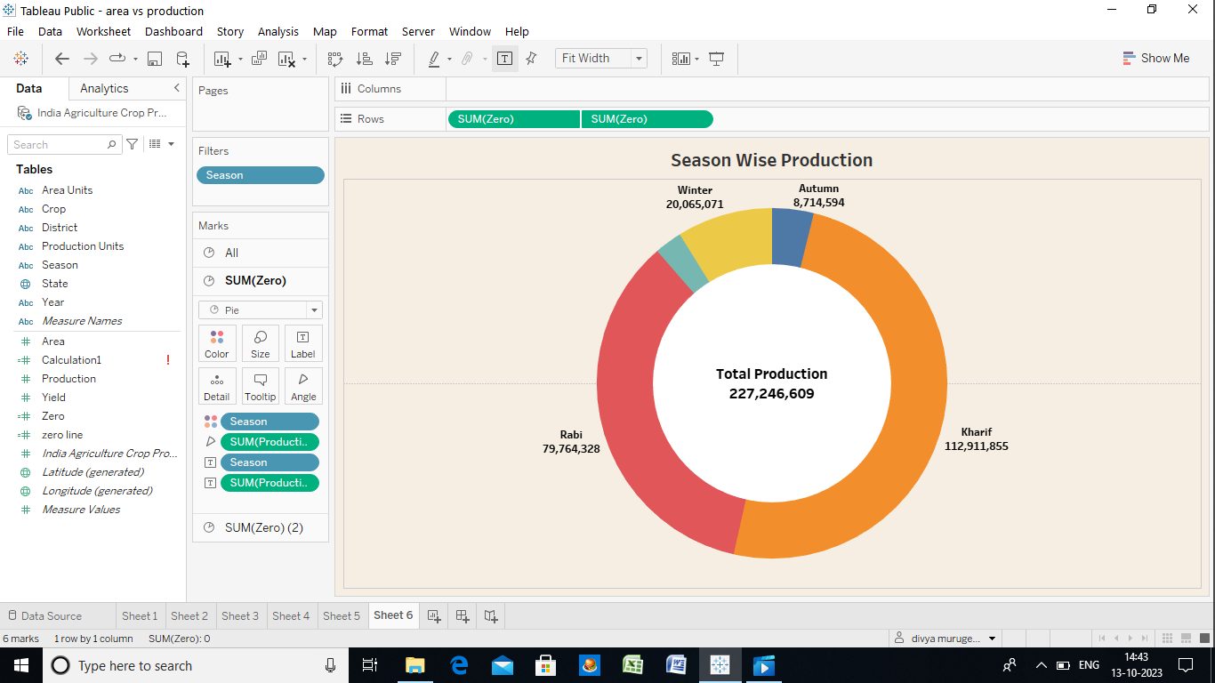



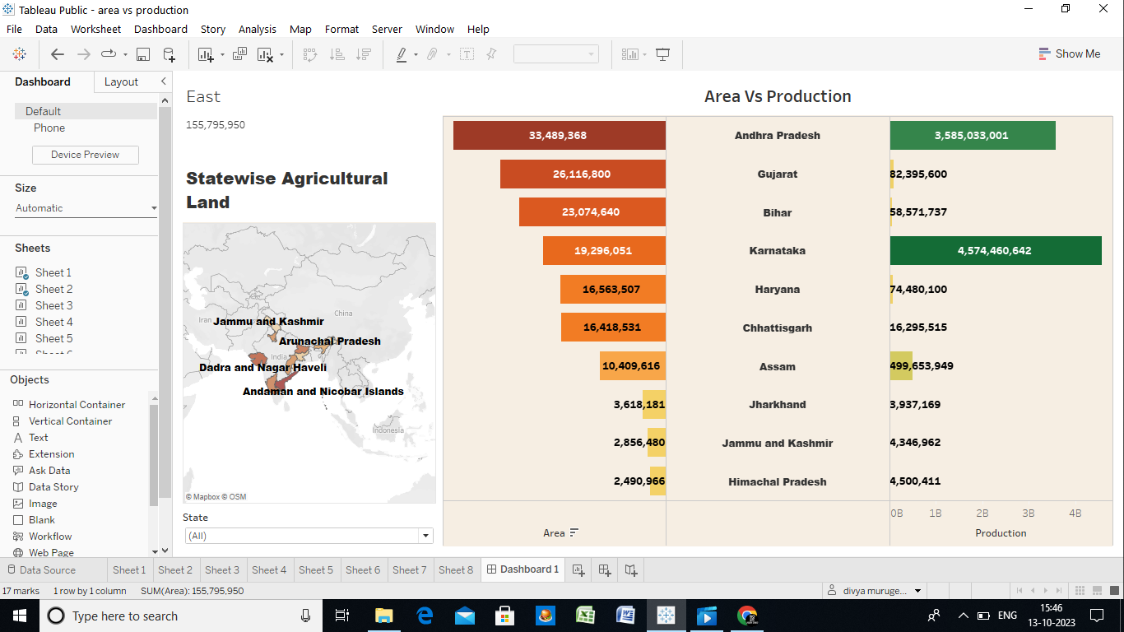

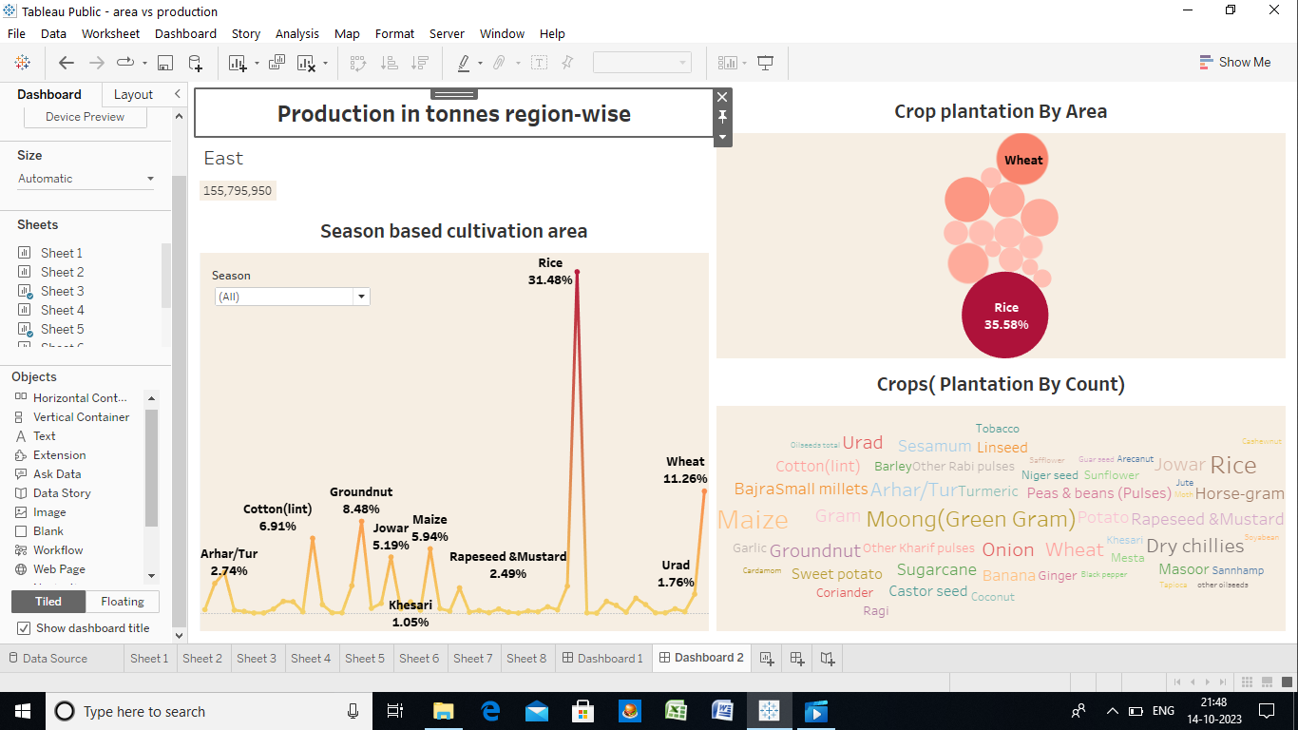

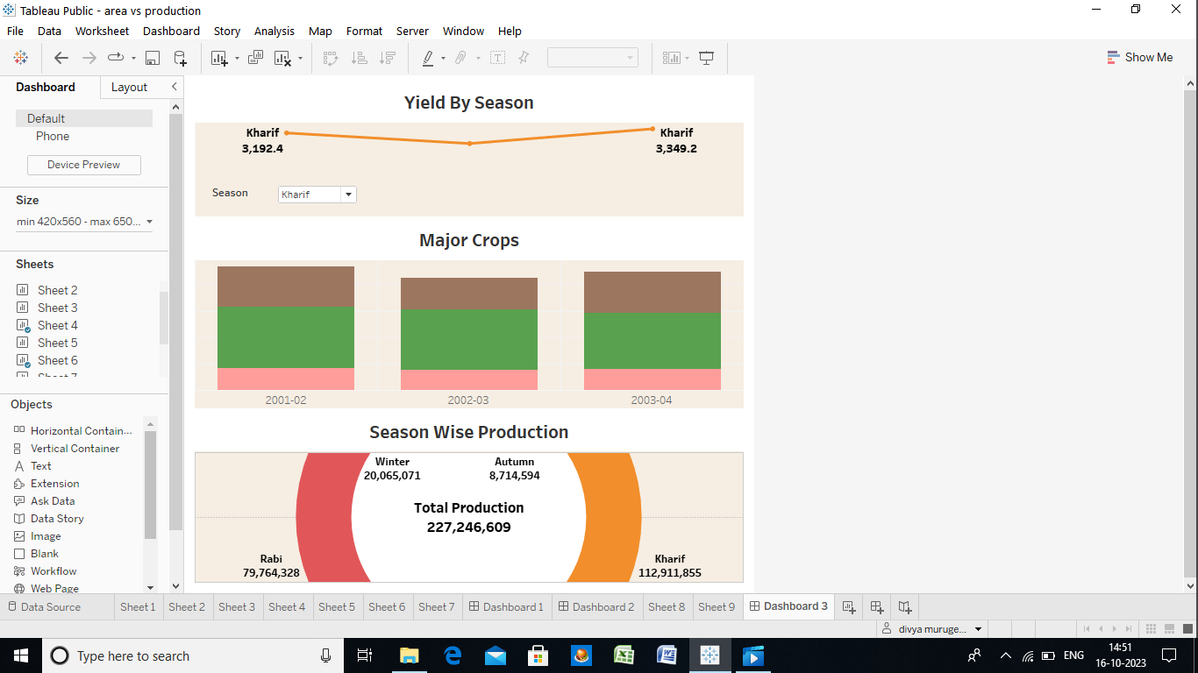



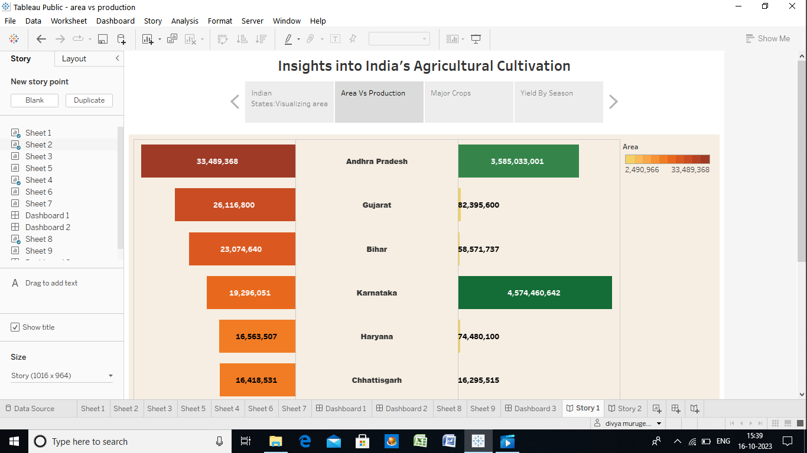

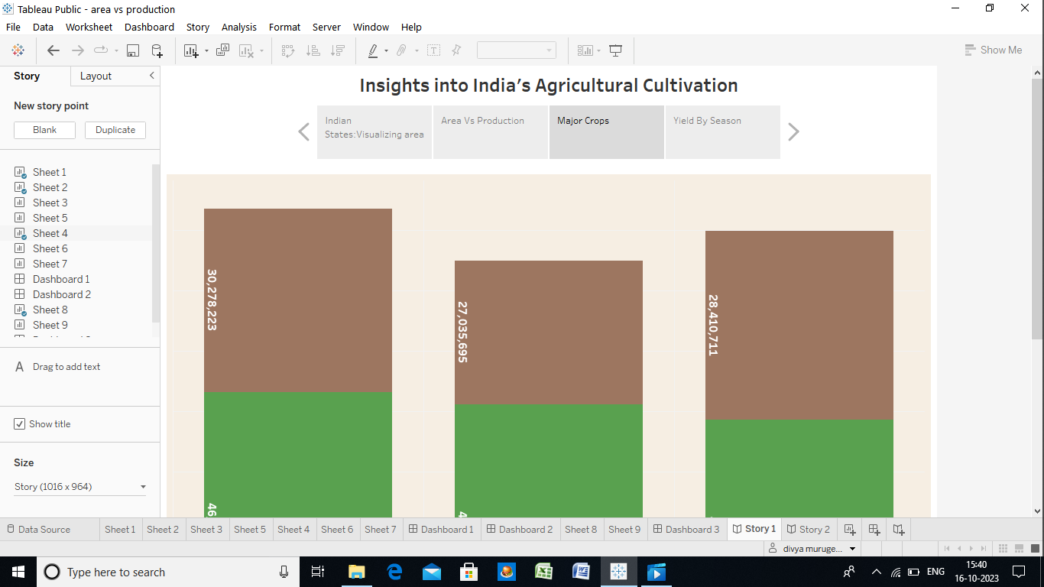

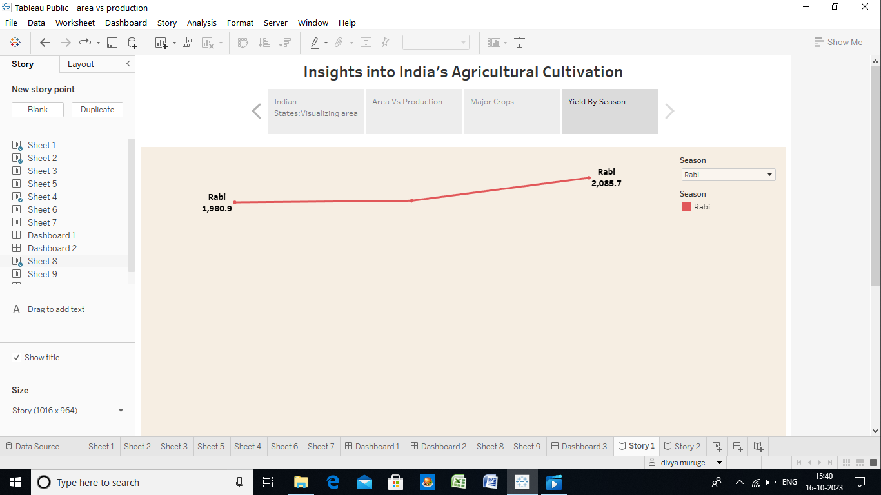

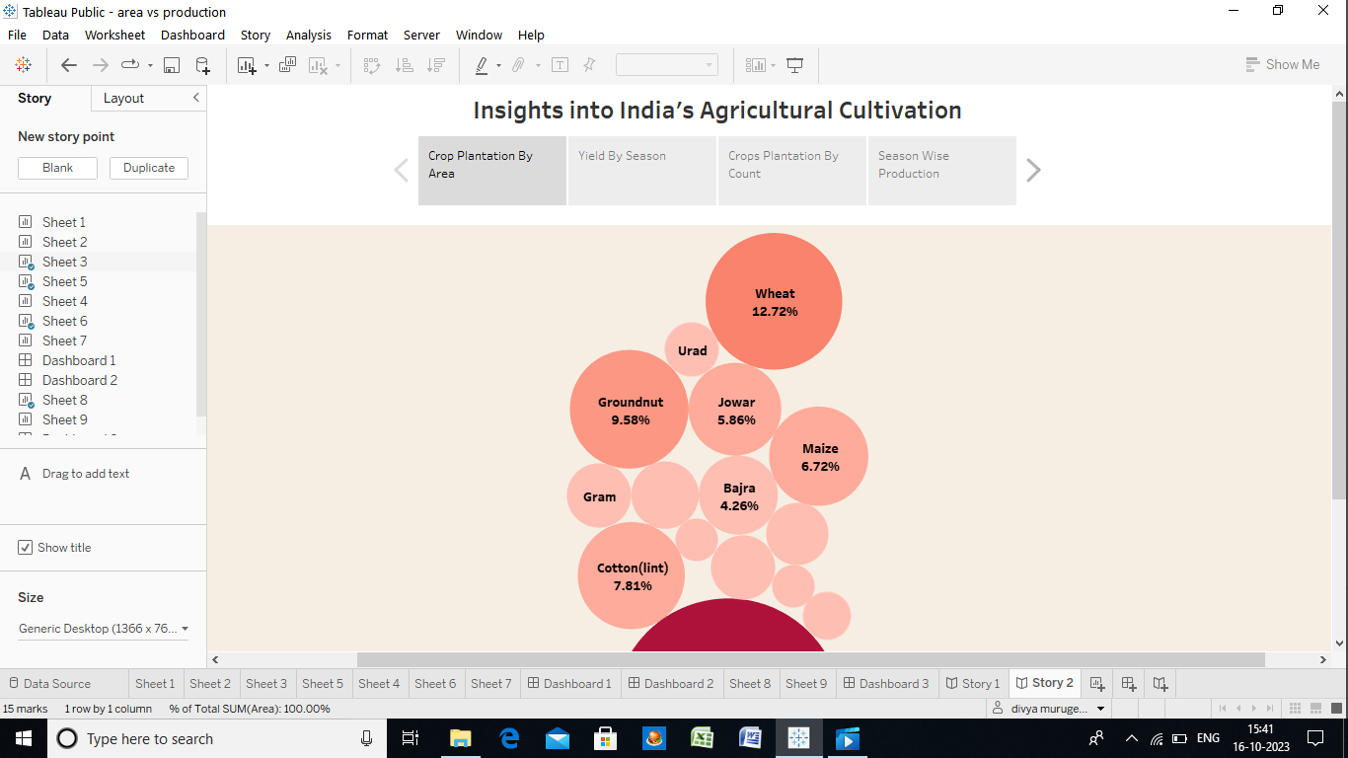

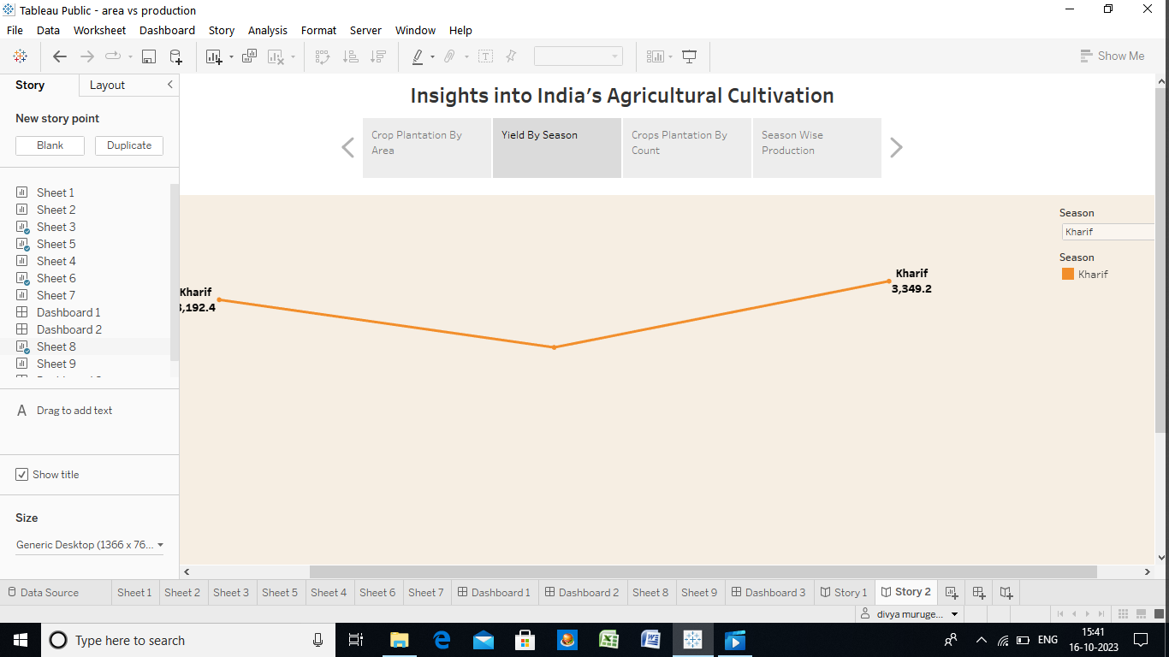

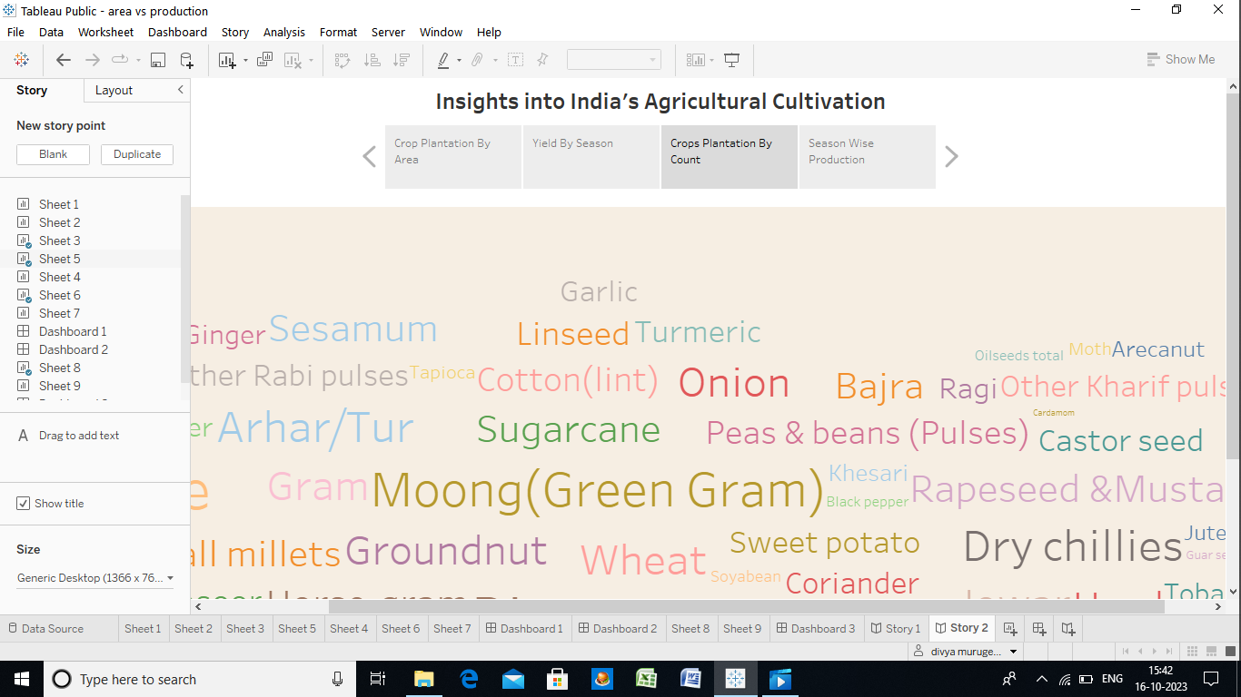

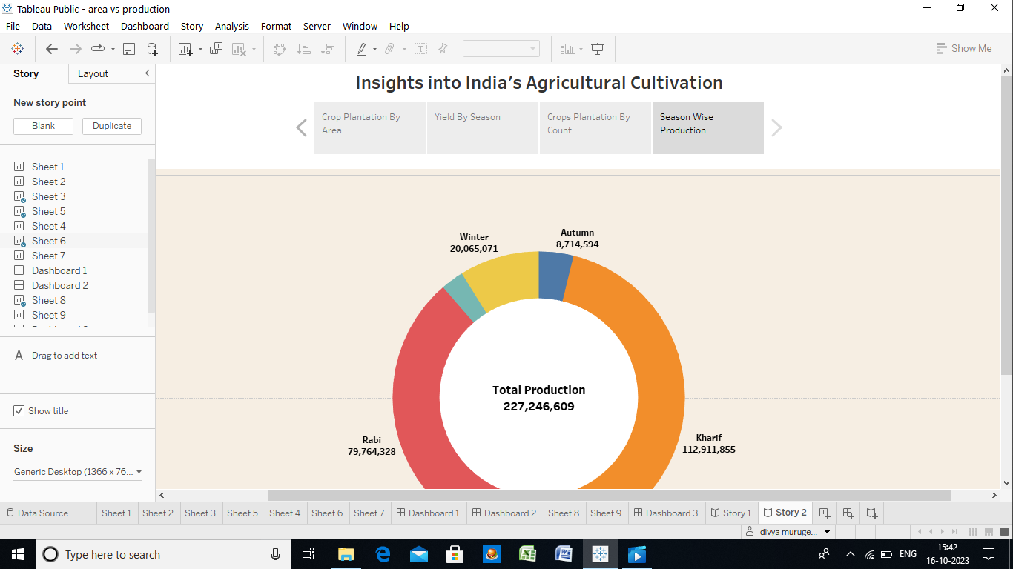

Agricultural trade

Major commodities imported to India are pulses, edible oils, fresh fruits and cashew nuts.  Major commodities exported by India are rice, spices, cotton, meat and its preparations, sugar, etc.  Over the past few decades, the share of agricultural imports in total imports has increased from 2.8% in 1990-91 to 4.2% in 2014-15, whereas the share of agricultural exports has reduced from 18.5% to 12.7%.

**Factors affecting agricultural productivity**

**Increase in small land holdings**

140 million hectare of land is used as agricultural area, as of 2012-13. Over the years, this area has been fragmented into smaller pieces of land. The number of marginal land holdings (less than one hectare) increased from 36 million in 1971 to 93 million in 2011. Marginal and small land holdings face a number of issues, such as problems with using mechanisation and irrigation techniques.

Since smaller land holdings are either fragments of larger holdings which have been passed on within the family or have been informally leased by a large holder, farmers who cultivate these holdings often do not have a formal lease agreement.  The absence of such land records does not allow these farmers to access formal credit or be eligible for government benefits such input subsidies or crop insurance schemes.

**Inadequate access to crop insurance**

As of 2011, about 10% of Indian farmers were covered under a crop insurance scheme. Some persistent issues with the crop insurance system include (i) unawareness about insurance schemes, (ii) inadequate coverage of insurance schemes, (iii) assessment of the extent of damages in case of crop losses, and (iv) timely settlement of claims.

The Standing Committee on Finance has recommended that assessment of crop damage should be completed and compensation should be deposited directly into farmers’ accounts in a timely manner. In addition, to reduce the seeking of unproductive credit, the government should create awareness about what crops should be grown based on the quality of soil and incidence of rainfall, etc. in different regions.

**Availability of water**

Currently, about 51% of the agricultural area cultivating food grains is covered by irrigation.[[36]](https://prsindia.org/policy/analytical-reports/state-agriculture-india" \l "_edn36)  The rest of the area is dependent on rainfall (rain-fed agriculture).  Sources of irrigation include ground water (wells, tube-wells) and surface water (canals, tanks).  Table 5 shows the various sources of irrigation used in agriculture.

 There is a need to improve the efficiency of water use, especially in agriculture.  Irrigation currently consumes about 84% of the total available water in the country.

 Nearly 65% of the irrigated land holdings use ground water sources such as tube wells and wells for irrigation.

FUTURE SCOPE

B.Sc Agriculture graduates can explore the sea of opportunities in both the public and private sectors. They can start their career as Agriculture Officer, Assistant Plantation Manager, Agricultural Research Scientist, Marketing Executive, Business development executive, and many more.

CONCLUSION

The agriculture industry is one that needs to be preserved in order to sustain life. Without agriculture there would be no food, and without food there would be nothing.

VIDEO DEMONSTRATION LINK

https://drive.google.com/file/d/1GCV7t9hHeylpdPVsFFGRgwR4fbNi69DW/view?usp=drivesdk